**10. Photos taken in 2003 after the bushfire and repeated in 2007 and 2013**

Four sets of photos were taken at GPS positions (GDA94) according to this table:

|  |  |  |  |  |  |
| --- | --- | --- | --- | --- | --- |
| Position No. | Easting (GDA) 068…. | Northing (GDA) 608… | Photo direction | Photo identification | Description |
| 1 | 3844 | 6261 | S | a03, a07, a13 | Red and Yellow Box |
| 2 | 3816 | 6226 | NW | b03, b07, b13 | Cattle pond |
| 3 | 3506 | 6135 | S | c03, c07, c13 | Tree stump |
| 4 | 3776 | 6200 | SE | d03, d07, d13 | Fence post hill |

Photos are stored under their identification number. Below are copies:

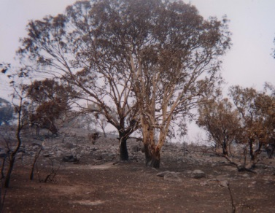

a03

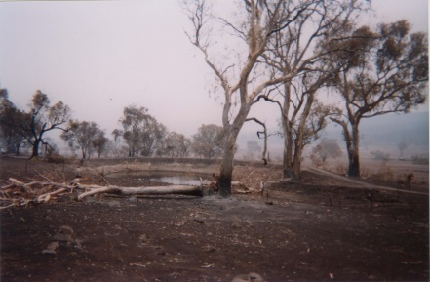

b03

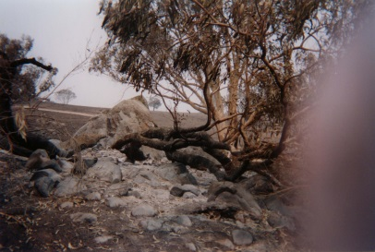

c03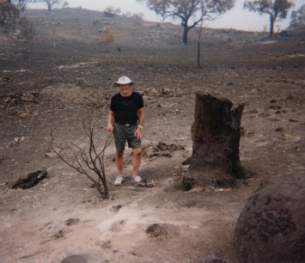

d03

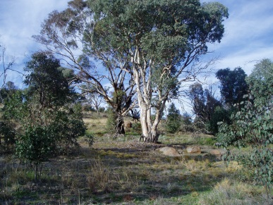

a07

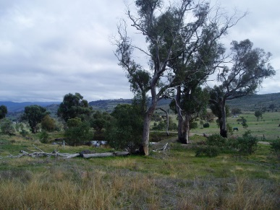

b07

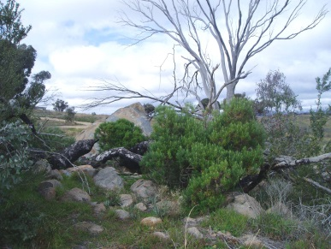c07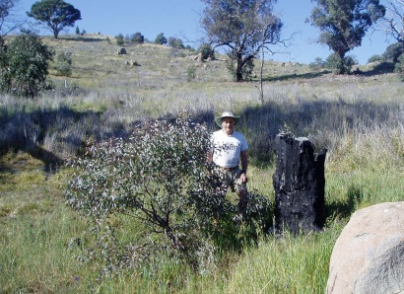

d07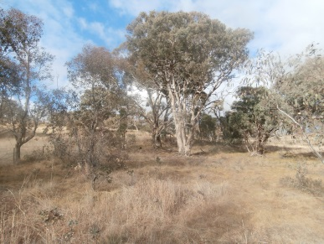

a13

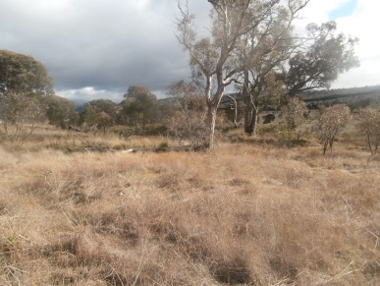

b13

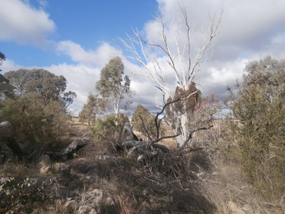

c13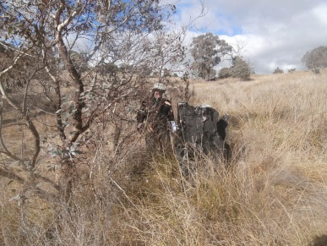

d13